HCI Assignment 1



Submitted by
Areef ur Rahman
Abdullah Maqbool
L1F23BSSE0389
L1F23BSSE0391

Submitted To
Noman Nazar
Group Details
Project Title: Chef Finder
Abdullah Maqbool (Project Leader) | Areef ur Rahman

- Idea
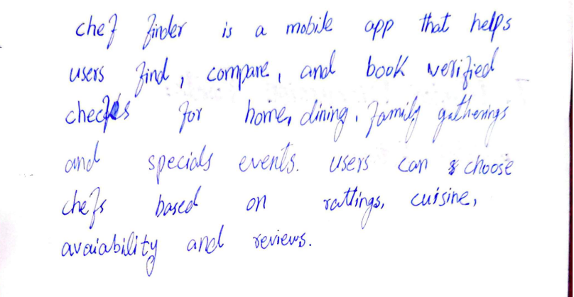

- Problem Description
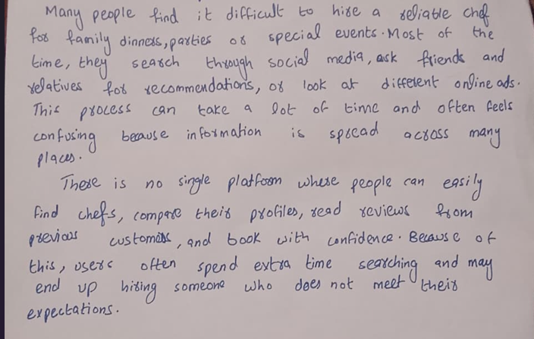

- Facilitator
Abdullah Maqbool

- Solution Description
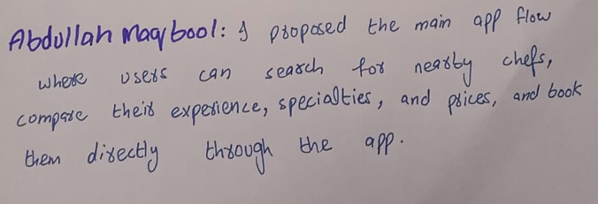
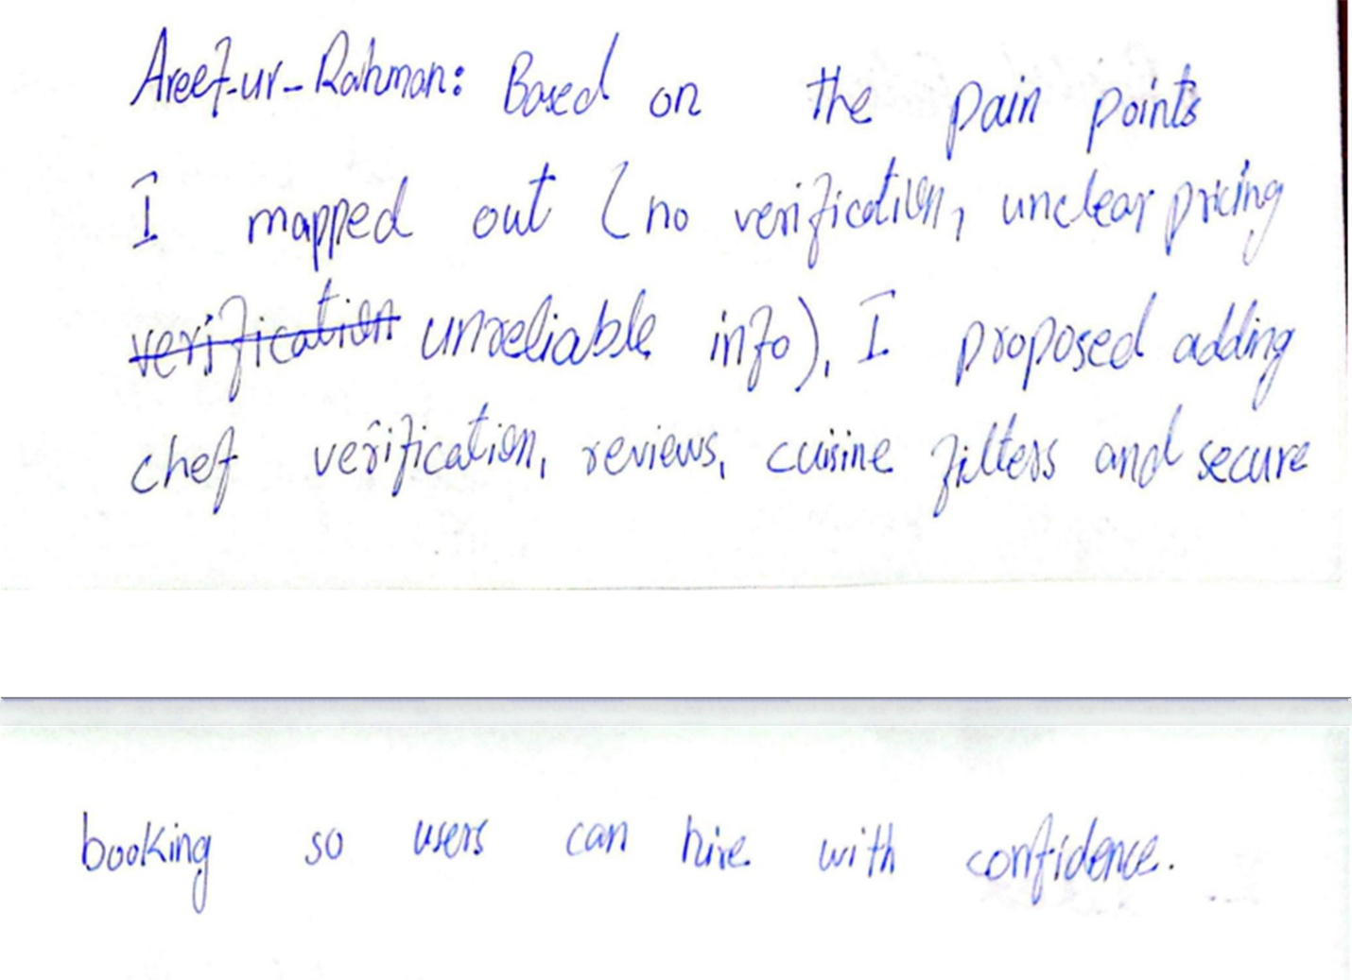

- 8-Panel Storyboards

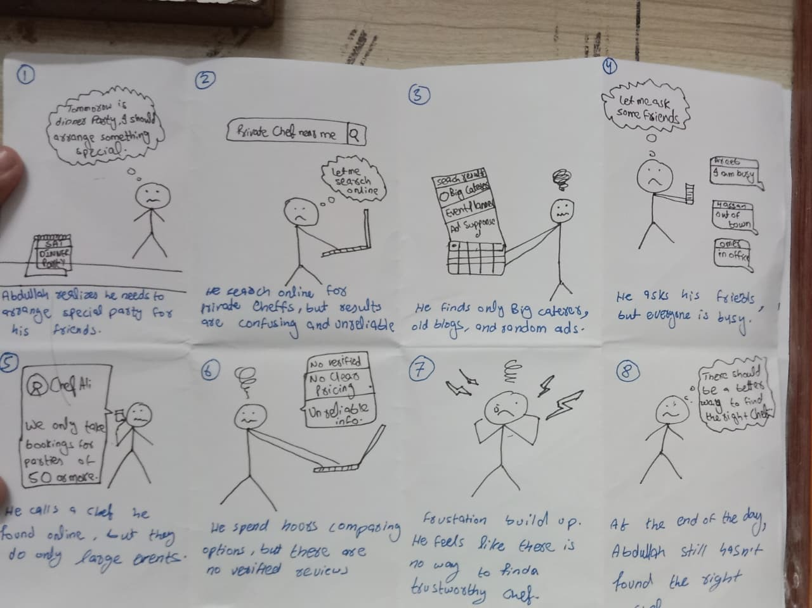
Image 01
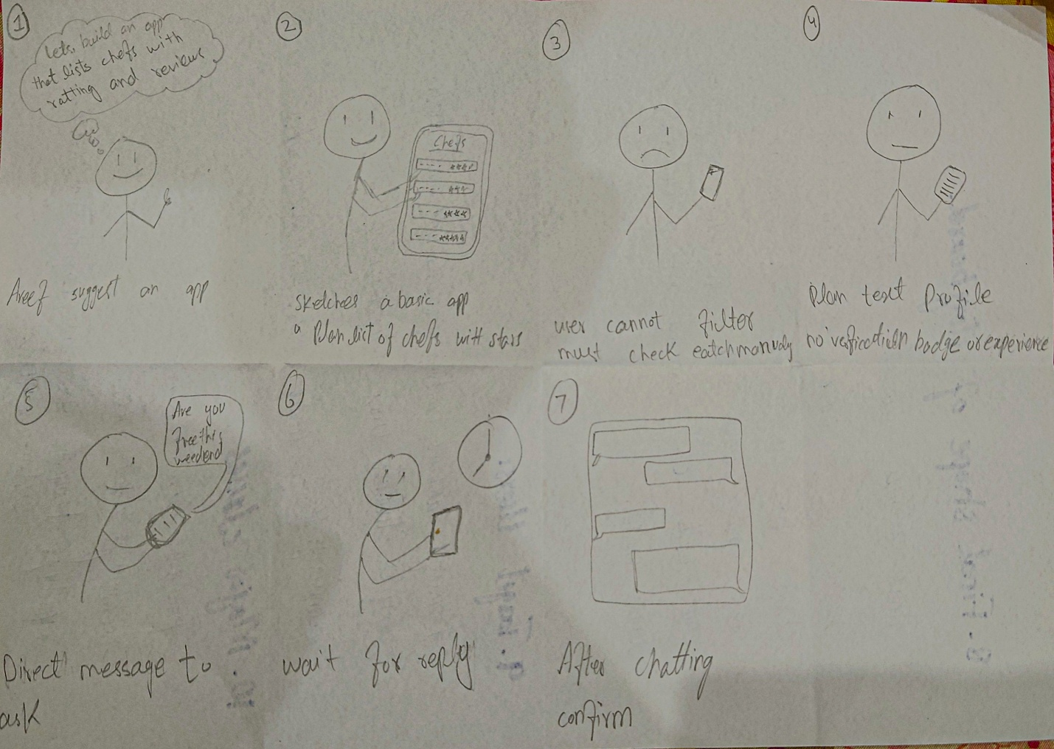
Image 02
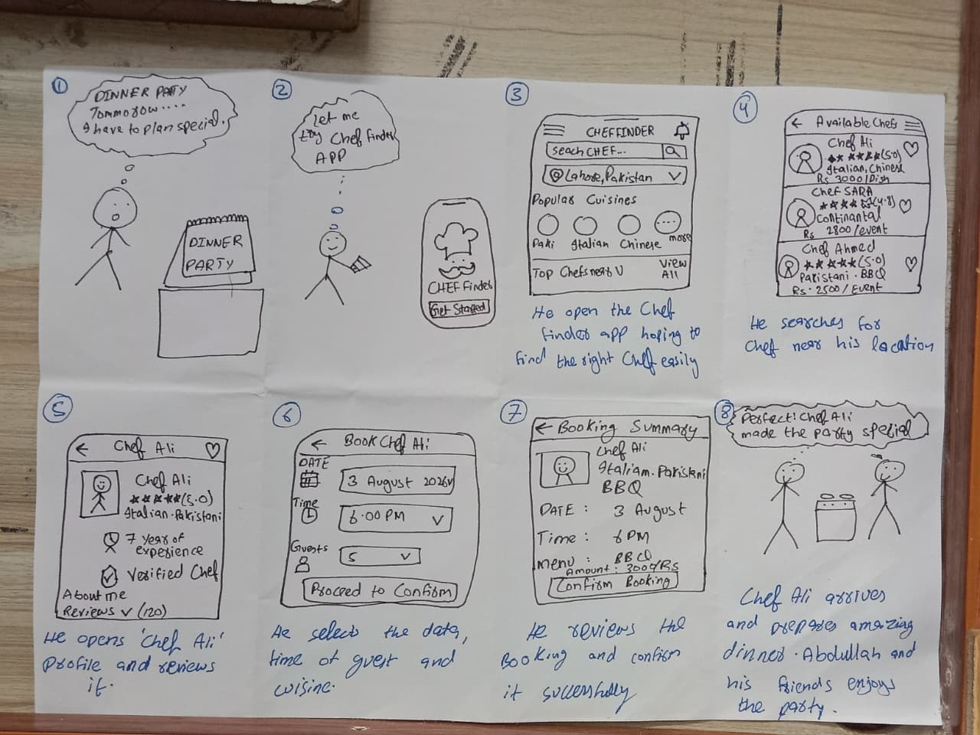
Image 03

- Major Discussion Points
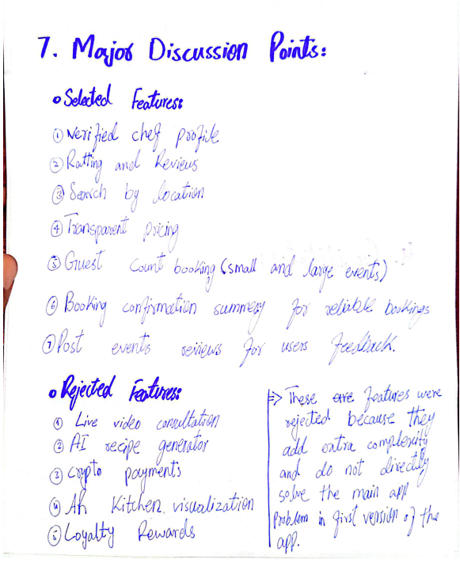

- Final Shape of Storyboard
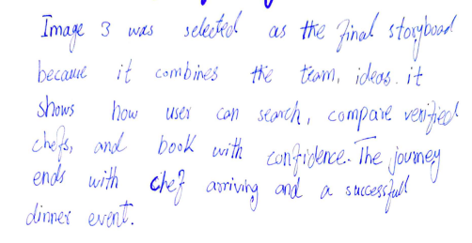
- Targeted Users
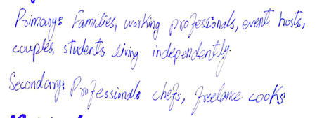

10. Major Classes
